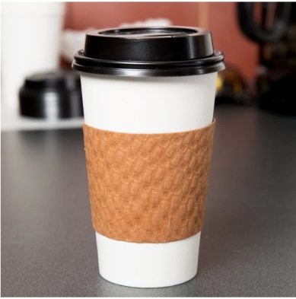
Classic White Thermo Grip Disposable Travel Coffee Cup With Sandy Isolating Heat Sleeve And Black Lid 12oz. 350ml
Convenient Thermo Travel Cap useful to use with any to-go beverages such as hot chocolate, all variants of the coffee and the tea or the mulled wine. This cap is perfect for any beverages offerings in your convenience store, snack shack, concession stand, take-out operation and other establishment.
The highest quality classical white thermo coffee cup. Choose this cup and you personally will feel all the benefits from this product.
Classical shape.
Thermo Grip Cap has the classical white color and the suitable volume 12oz. 350ml.
High-quality materials.
All parts are made from the high-quality materials. This will let you perceive an odor of your favorite beverage free from chemical’s smells and enjoy the pure taste of your favorite coffee.

No soaks.
The cap is made from the hard and qualitative paper, which is saving the shape for a long time without getting soft and soaks.
Strong construction.
Strong construction of the cup and the good fixing of the lid provide less cracking.

Thermo isolating sleeve.
The sandy thermo isolating sleeve will save your fingers from the high temperature, but will let your beverage stay hot longer.
Non-slipping surface.
The non-slipping surface of the thermo grip will give you convenience, safety and confidence, when you hold and carry this cap.
Convenient lid.
Extremely convenient black lid is made to fit 12oz cup. When you place the lid over the cup it makes "click" that means that lid is fixed and cap is ready to use.
Universal sipping hole.
Universal sipping hole of the lid is made to accept stirrers and straws that makes convenient to mix the sugar and to drink the hot beverage.
Improved flow.
The lid has tiny air hole which provides improved flow of the beverage.
Exclusively designed bottom.
The warranty that cups won't stick together gives the exclusively designed bottom flairs out.
The thermo cap convenient to use:
- when you travel,
- with the coffee to go,
- in the office or break rooms,
- in school campuses,
- on the parties or weddings.
Choose Classic White Thermo Grip Coffee Cup and your favorite hot coffee can always be with you.

